SYSC 2310 A Introduction to Digital Systems

Lab Report

Lab 6: Sequential Logic Circuits

Student Name: Riya Arora

Student ID: 101190033

TA Name: Ramy Mohamed

Lab Section: L2E

Lab Date: December 5th, 2021

Date Completed: December 8th, 2021

Pre-Lab

Binary Counter Circuit Design

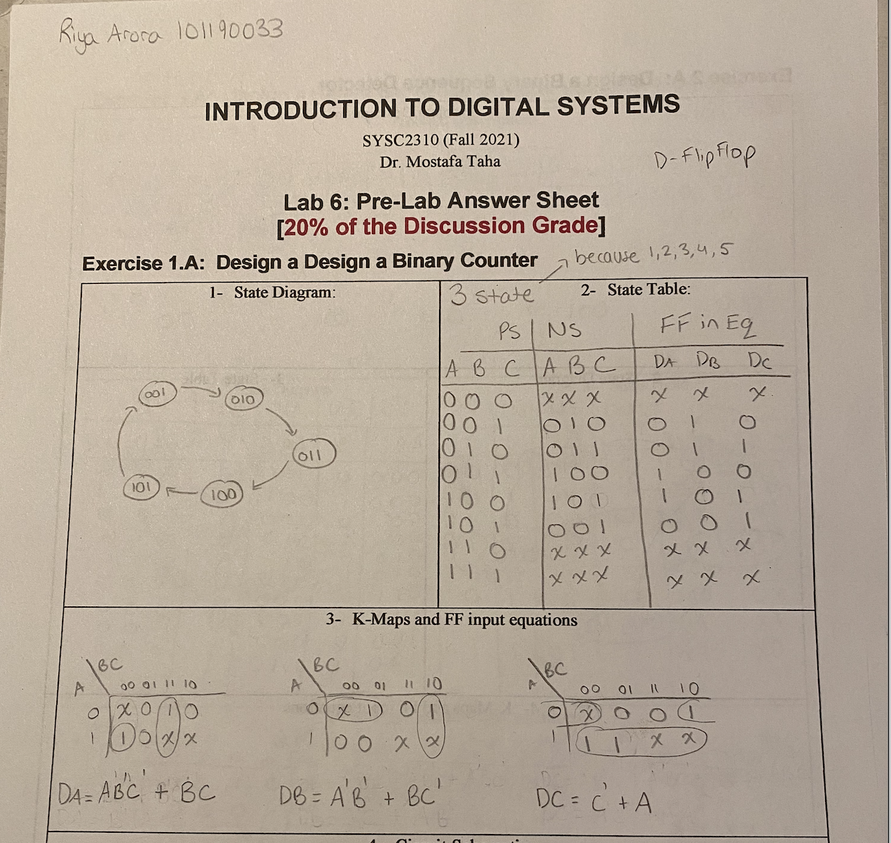

Binary Counter Circuit

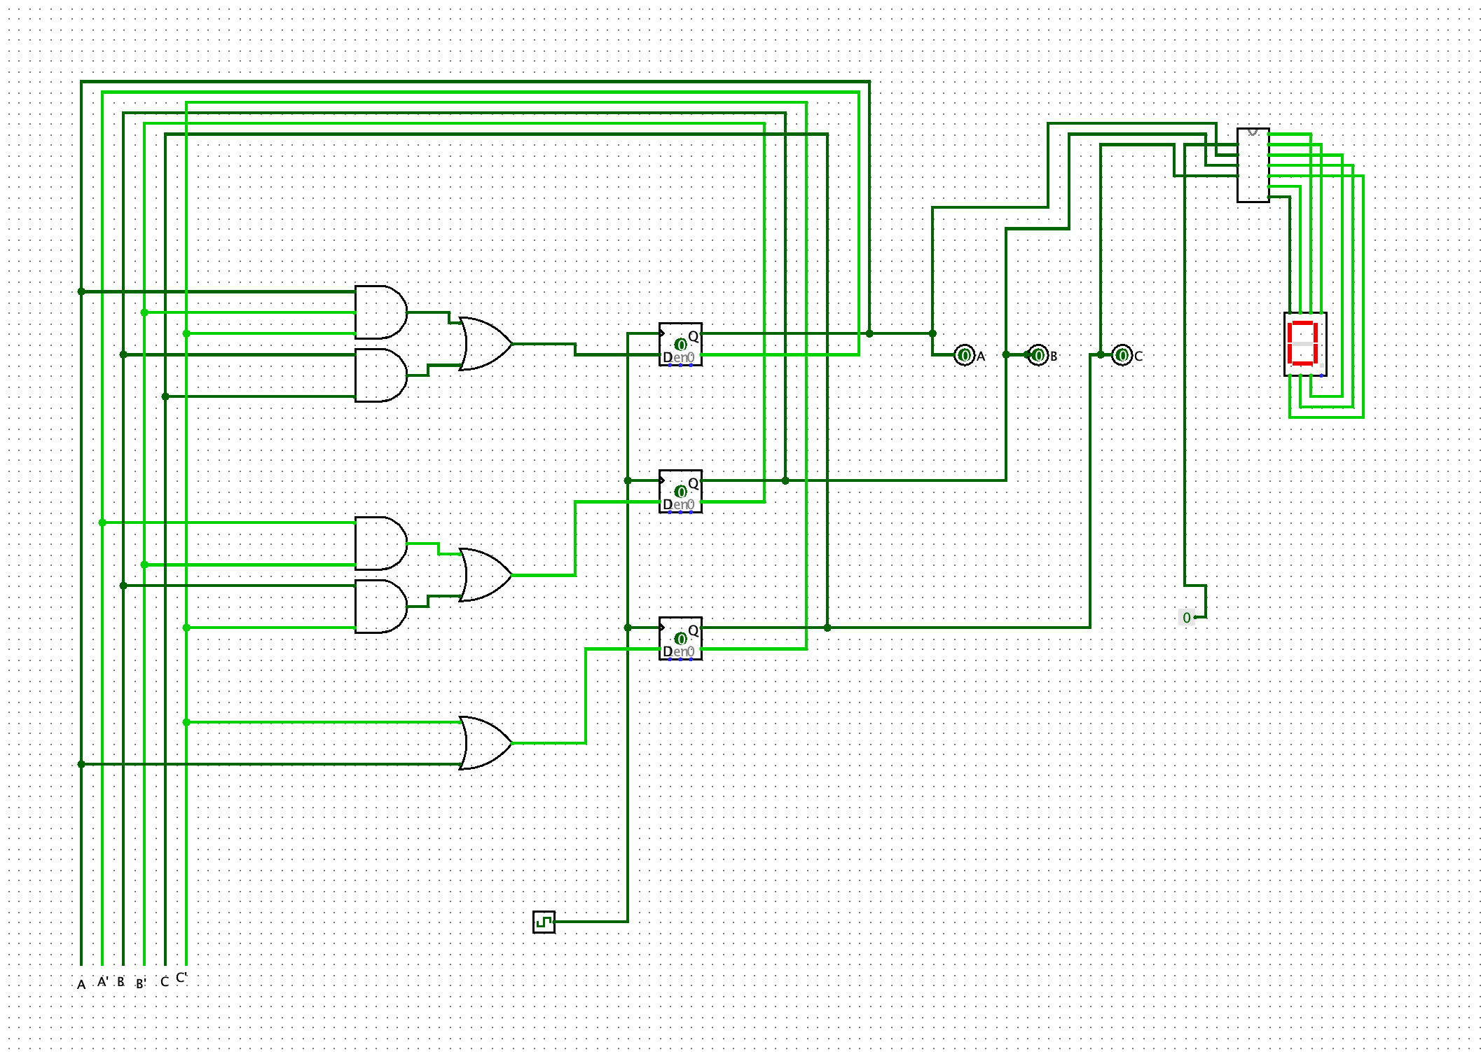

Binary Counter Circuit Logging

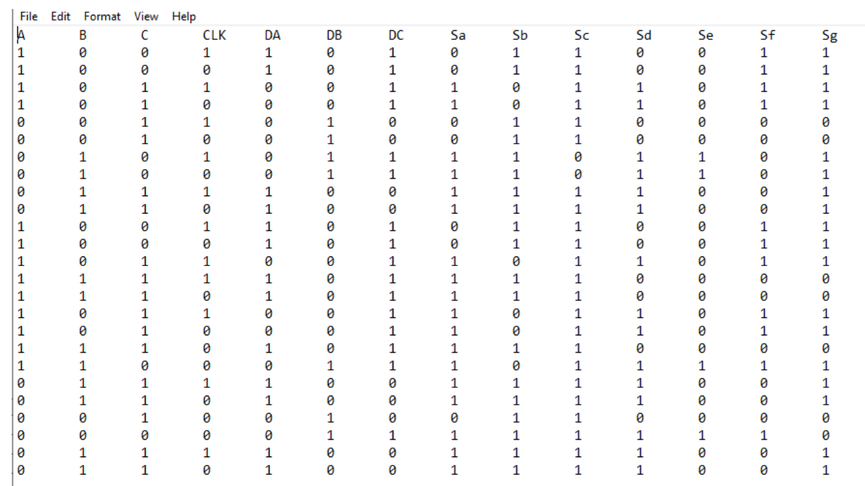

Binary Sequence Detector Design

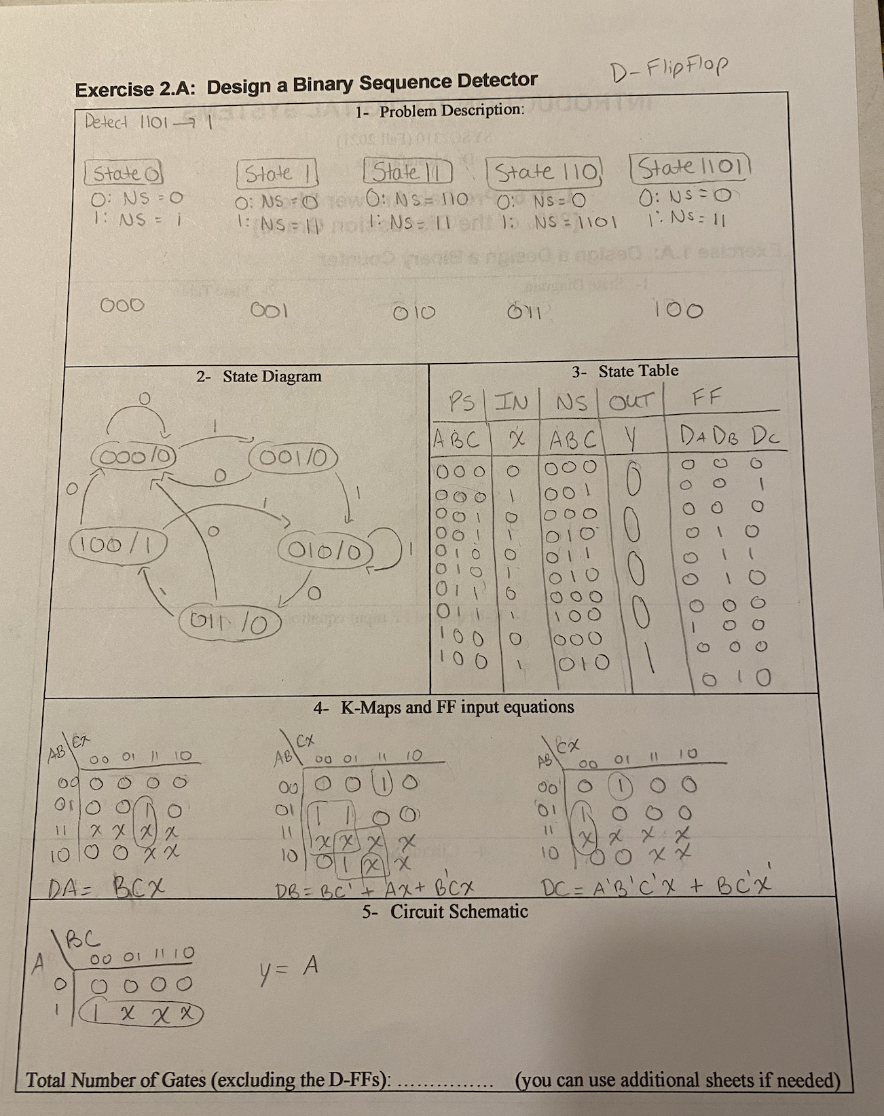

Binary Sequence Detector Design circuit

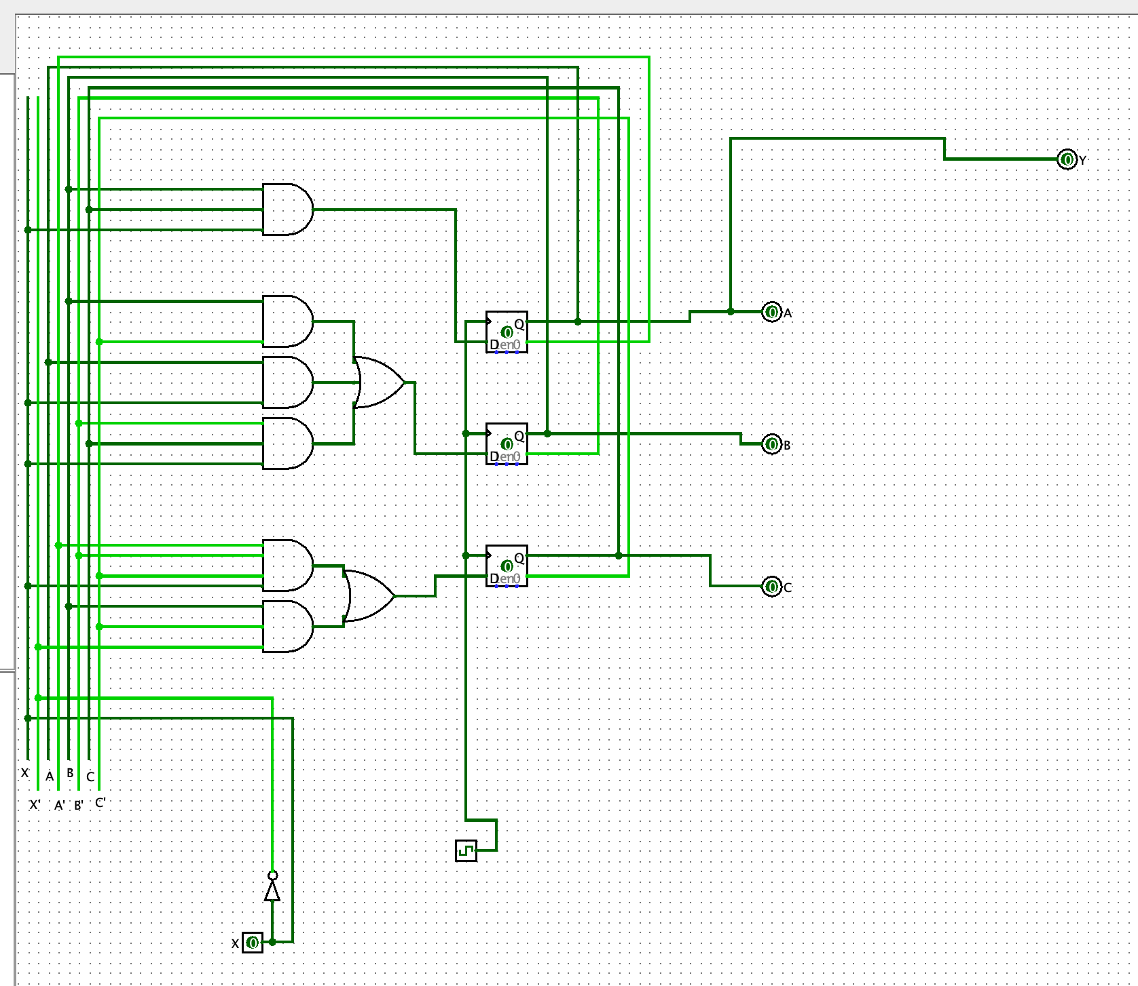

Binary Sequence Detector Design logging

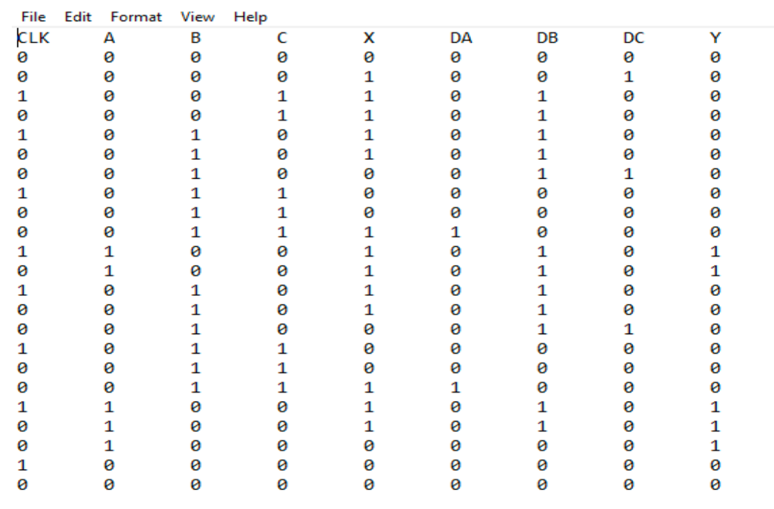

Binary Sequence using Jk Flip flops design

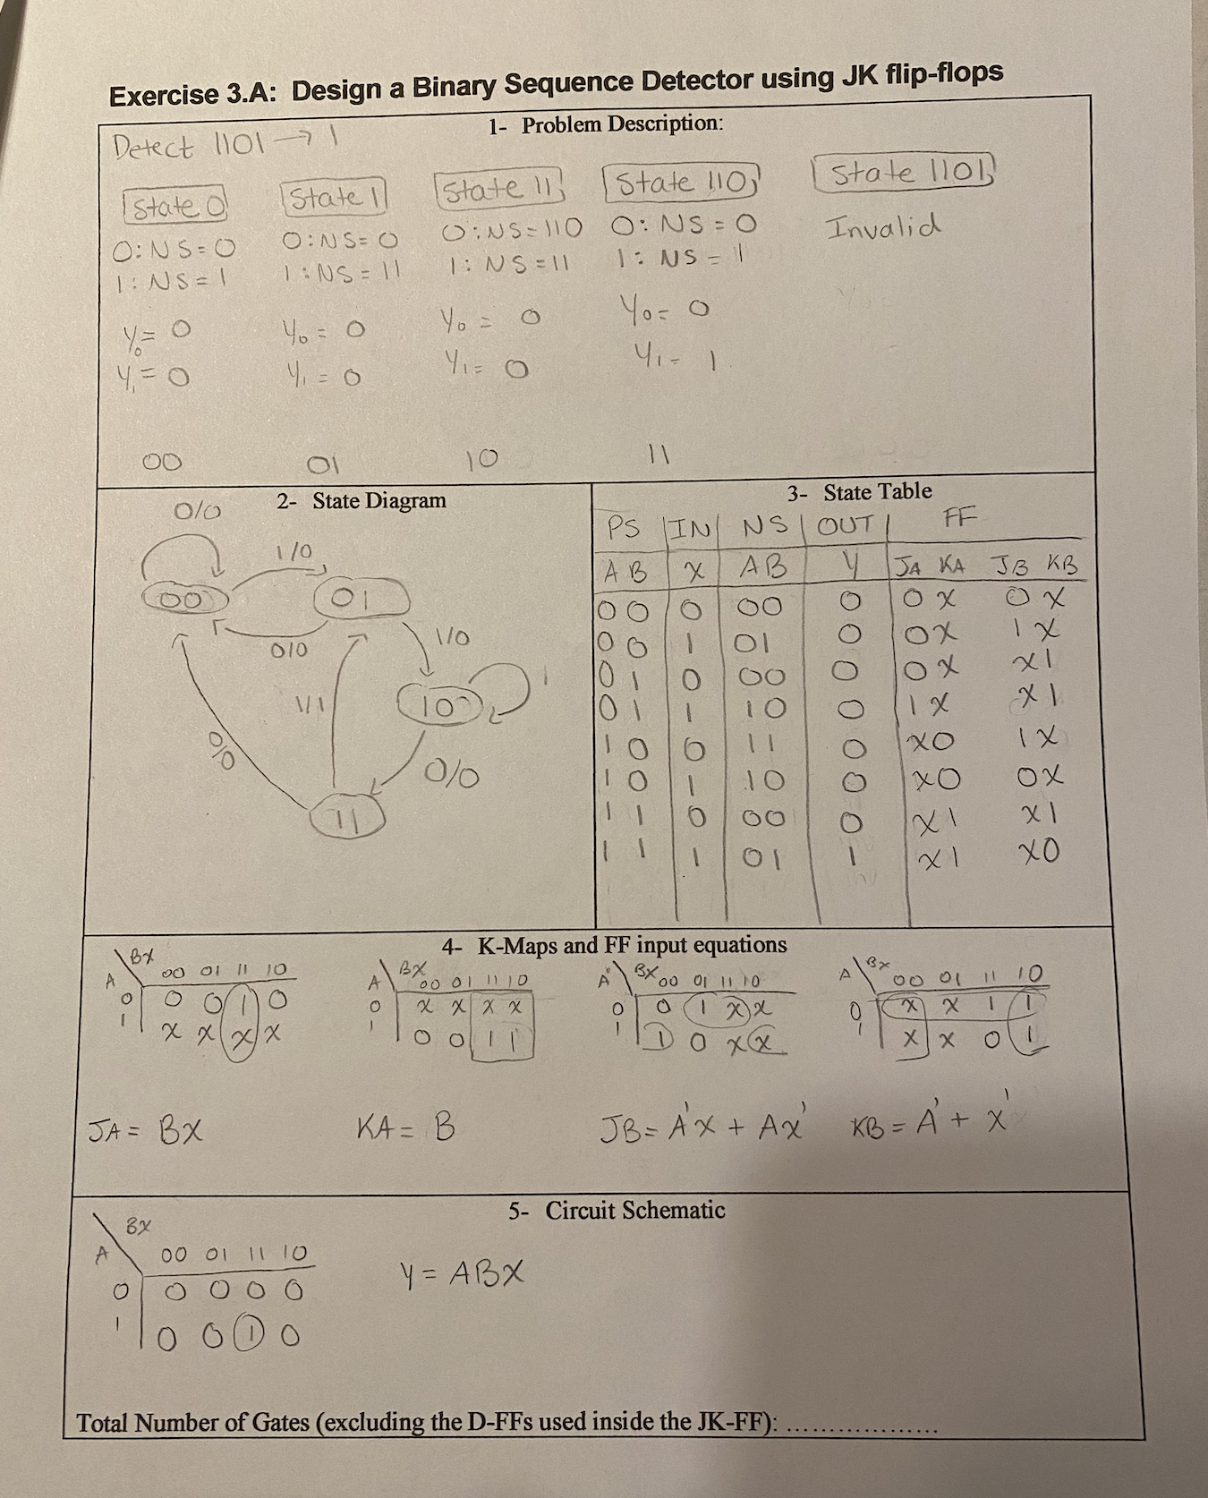

Binary Sequence using Jk Flip flops design circuit

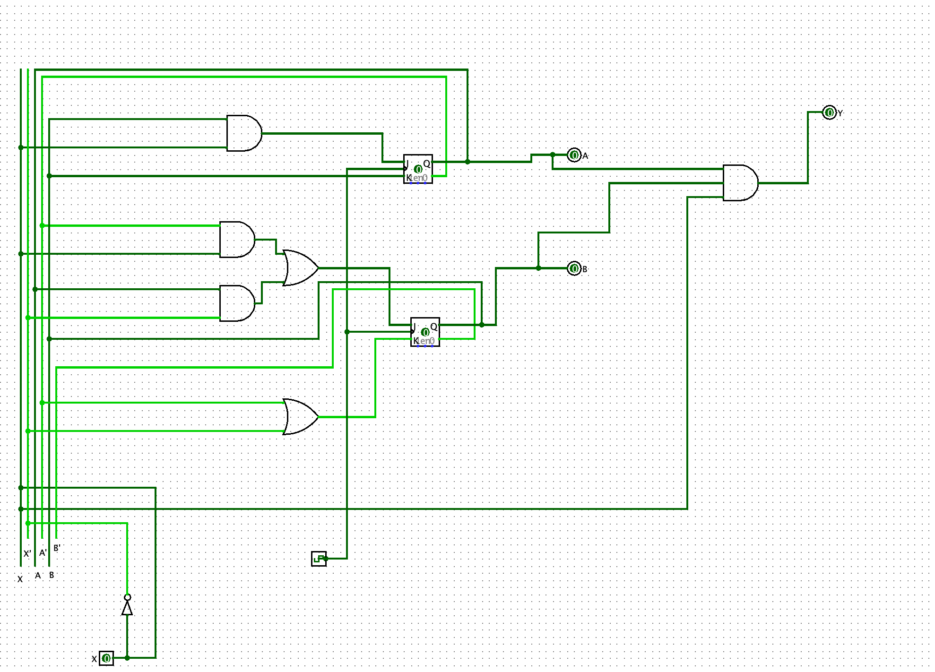

Binary Sequence using Jk Flip flops design logging

